Resume Niteesh Chaudhry 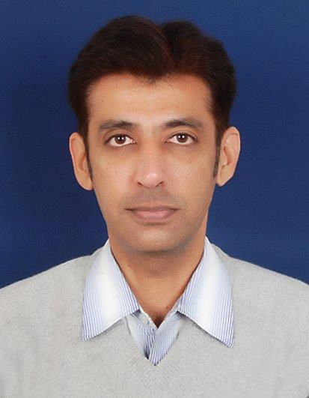
C-2/1258, Palam Vihar,
Gurgaon
Tel. 9891964222
E-Mail- theniteesh@gmail.com
Objective
To have a meaningful role in the field of Strategy/Channel sales/distribution/promotions/marketing
Key Skills-
Modern trade/Online/Horeca sales management
Marketing Activations
General Trade sales management
Capability building of front line sales executives
Corporate sales management
Setting/startup operations (planning to execution)
New product launches
Distributors/Franchisee appointments and management
Snapshot
Company | Designation hold | Area | Period
Retail trainer with Future group (for Big bazaar,FBB,Brand factory,Hometown format) & also done PMKVY , ITC ,Unicharm & Jio training, and Sales/Operations projects with few fmcg startups | Retail & FMCG Sales trainer(RASCI certified) and own ecomm startup  pickmystar.com | India | Apr’15 onwards
Pro-Activ foods(bene-fit.in)  (Regular & organic olive oils, NSA jams) | National Manager ( S & M ) | National role(Modern trade,General trade,online,Horeca) | June’13 till Mar’15
Hindustan Unilever Ltd (HO-Mumbai) | Sr Key accounts executive | National MT role at Mumbai-HO(handling Walmart, Spencers, Bigbazaar, TPG, Tesco, ABRL, Metro,Spar) | Contd-till Aug’12
Hindustan Unilever Ltd | BDE | Delhi-NCR | July’07 to Dec’11-contd
Wrigley’s India | Sales Development Executive | North region | Feb.’05 to Sep’06
The Hindustan Coca Cola Beverages Ltd | Sales Executive | Jammu | Mar’04 to Jan.’05
Reliance Industries Ltd.(Petroleum Business) | Field Sales Officer | Delhi, Parts of Western UP | Feb.’02 to April’03
Hindustan Lever Ltd.(Soaps & Detergents Div) | Territory Sales Incharge | Delhi | March’99 to Jan’02

Key Achievements

Company | Achievement
 | Written a book on Retail named “ Hello Retail “
Pro-Activ Foods | Expanded distribution in MT/HORECA/Institution/Online/Corporate/innovative channels.
HUL | In short span Pureit gained highest market share in CnC and hyper MT chains(2012)
HUL | Highest sales growth of 40 %( 2011 Vis a Vis 2010) in North region
HUL | Got promoted as Senior BDE in March’11
HUL | Won best BDE award for 2010 for overall performance
HUL | Successful launch of Pureit through Distributor/dealer network in Delhi-NCR (in yr 2009)
HUL | Participated and represented HUL in key exhibitions like IITF and other events of CII/NGO’s
HUL | Started new channel of distribution such as Institutions, Consultant model, kiosks (2008 to 2010)
HUL | Successful launch of doctors program(2007-8)
Wrigley’s India | Implemented cash counter Merchandising strategy in North
Hindustan Coca Cola | Highest growing area (23%) with least credit to distributors
HLL | Highest growing area in 2000 and 2001
HLL | Won five top gun awards in one year

ons

QUALIFICATIONS

• AISSCE from Kendriya Vidhayalaya, Kota (Rajasthan)- Batch 1991-92.
• B.Sc (Statistics) from University of Jodhpur, Jodhpur (Rajasthan) - Batch 1993-96.
• PGDBM (Marketing) from New Delhi Institute of Management, New Delhi- Batch 1996-98

Personal Details

Date of Birth 19 October 1974
Languages Known Hindi, English, Punjabi
Marital Status Unmarried

(Niteesh Chaudhry)

https://in.linkedin.com/in/niteesh-chaudhry-615a8317

Key accounts/Modern trade role & responsibilities(Wal-Mart, Spencer’s, Big bazaar, TPG, Tesco, ABRL, Metro,Spar)

At Buyer/category level
Sales planning and implementing in consultation with buyers and regular communication/ negotiations with them
Making and executing specific customer micro-marketing plans- geography specific- based on customer feedback/understanding
Payment collections as per SOP and claims process in time
New product listing
Distribution in maximum number of stores
At Store level
Effective deployment of point of sales related collaterals in channels- visibility & sales aids
Deployment of store sales team, training as per agreed frequency
Execution with help of field force

